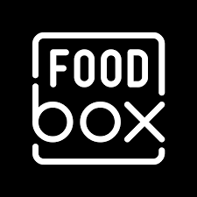

Capstone Project

**|Remya Pillai** |

**Cal Tech Post Graduate Program in Full Stack Web Development**

## **Screenshots Customer View**

**Welcome Page: Landing Page shows the carousel with Images and Order online button**

**Navbar has Menu , Login and Cart options**

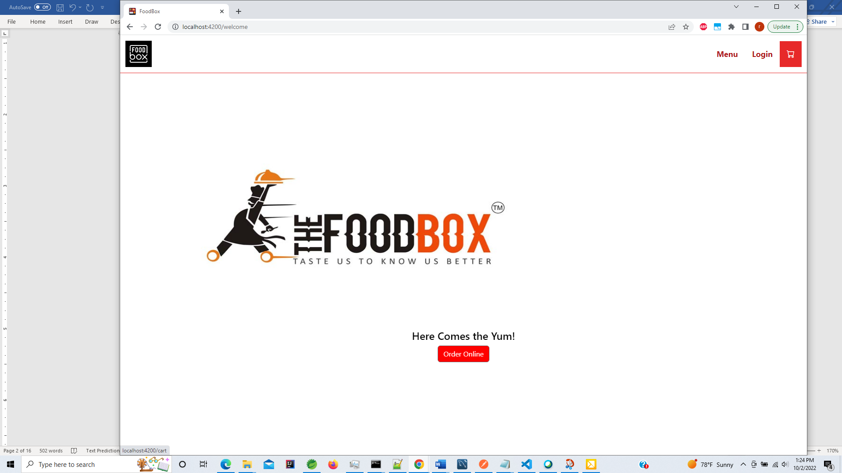

**Welcome Page shows a carousel slider displays most Popular Food Items .**

**Image changes every 3secs .**

**Also has Order online button that takes customer to Menu page**

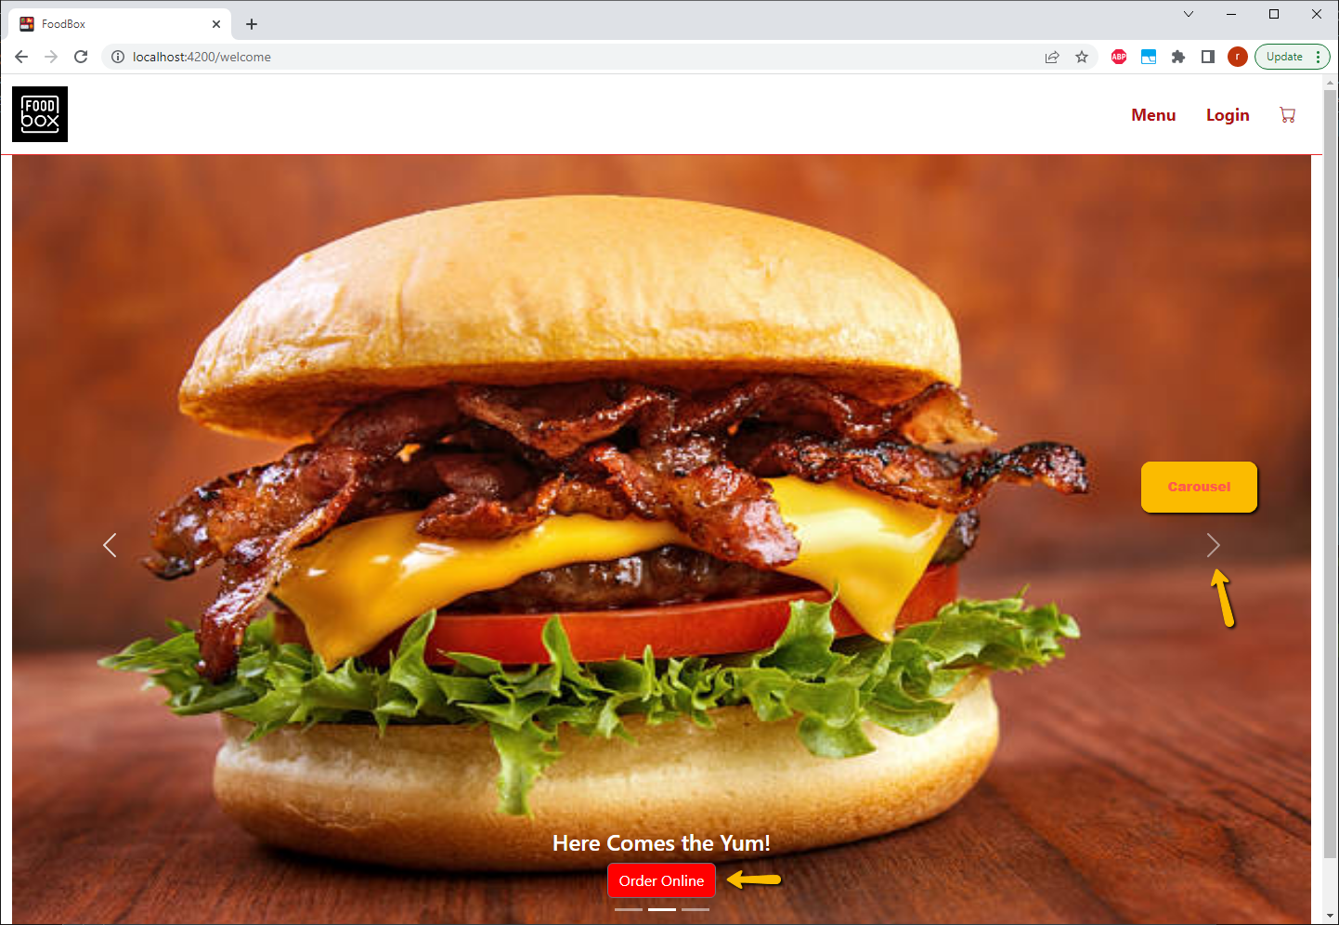

**Homepage of FoodBox website: displays most Popular Food Items on loading**

**Customer name /Login (if they already have an account or Sign Up if they are new customer)**

**Menu Option where they can browse food items.**

**Side Nav Bar to scroll through all different Categories**

**Cart Option – see cart contents**

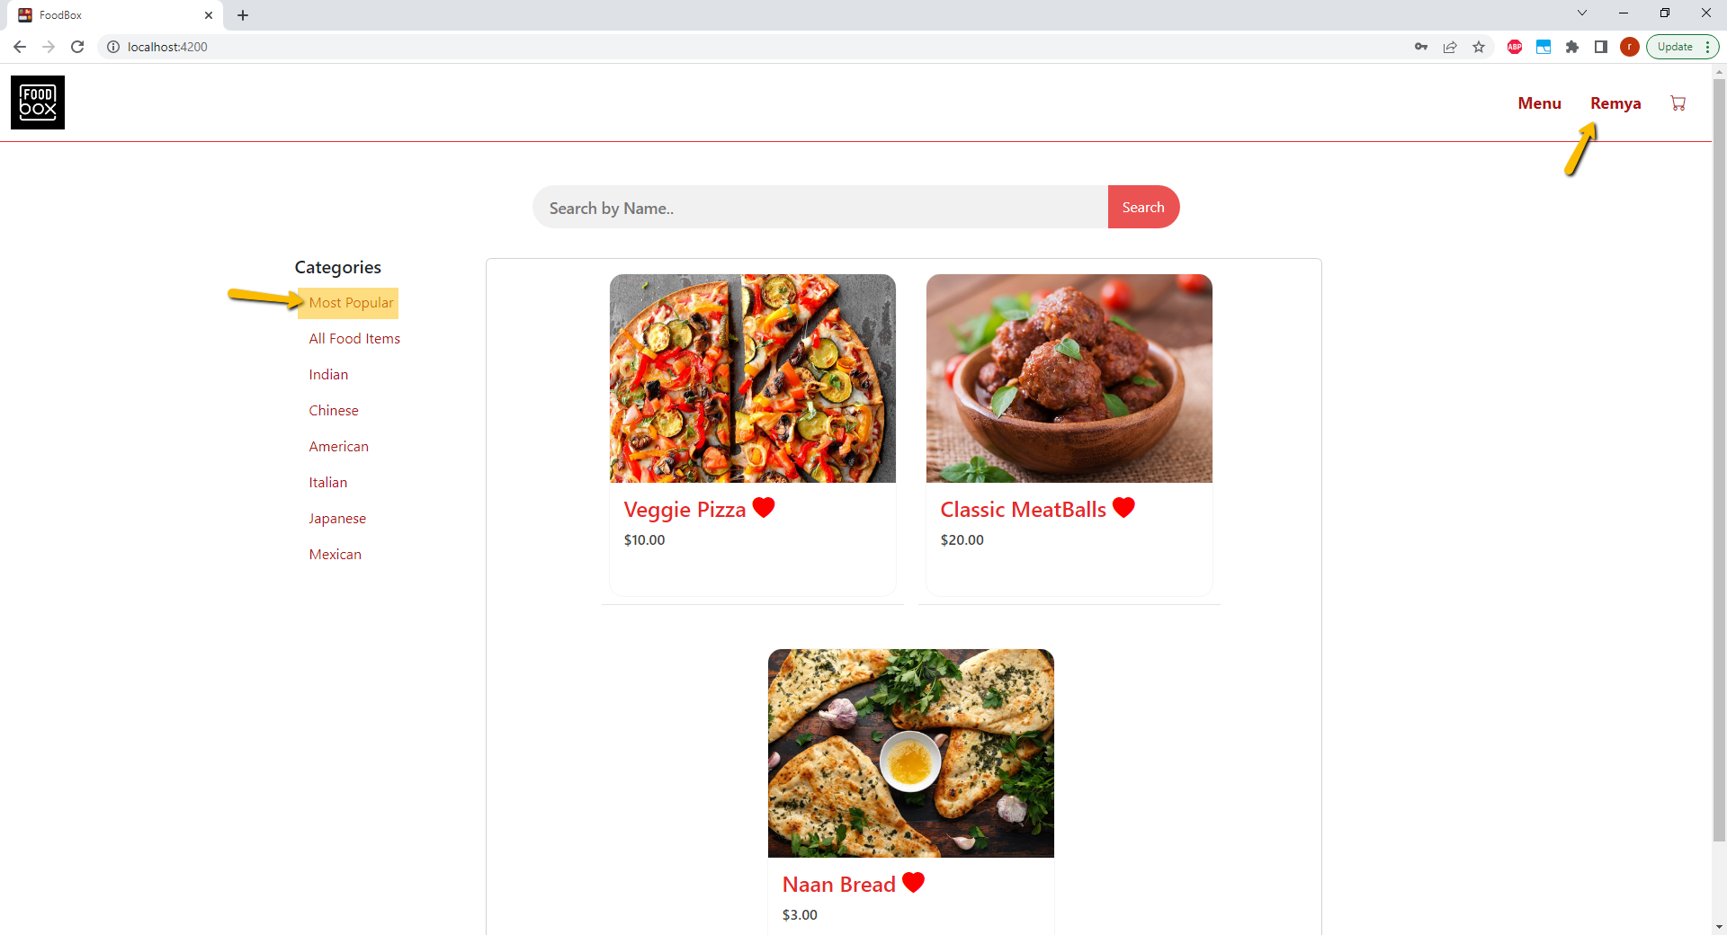

**All food items – display all available items to order**

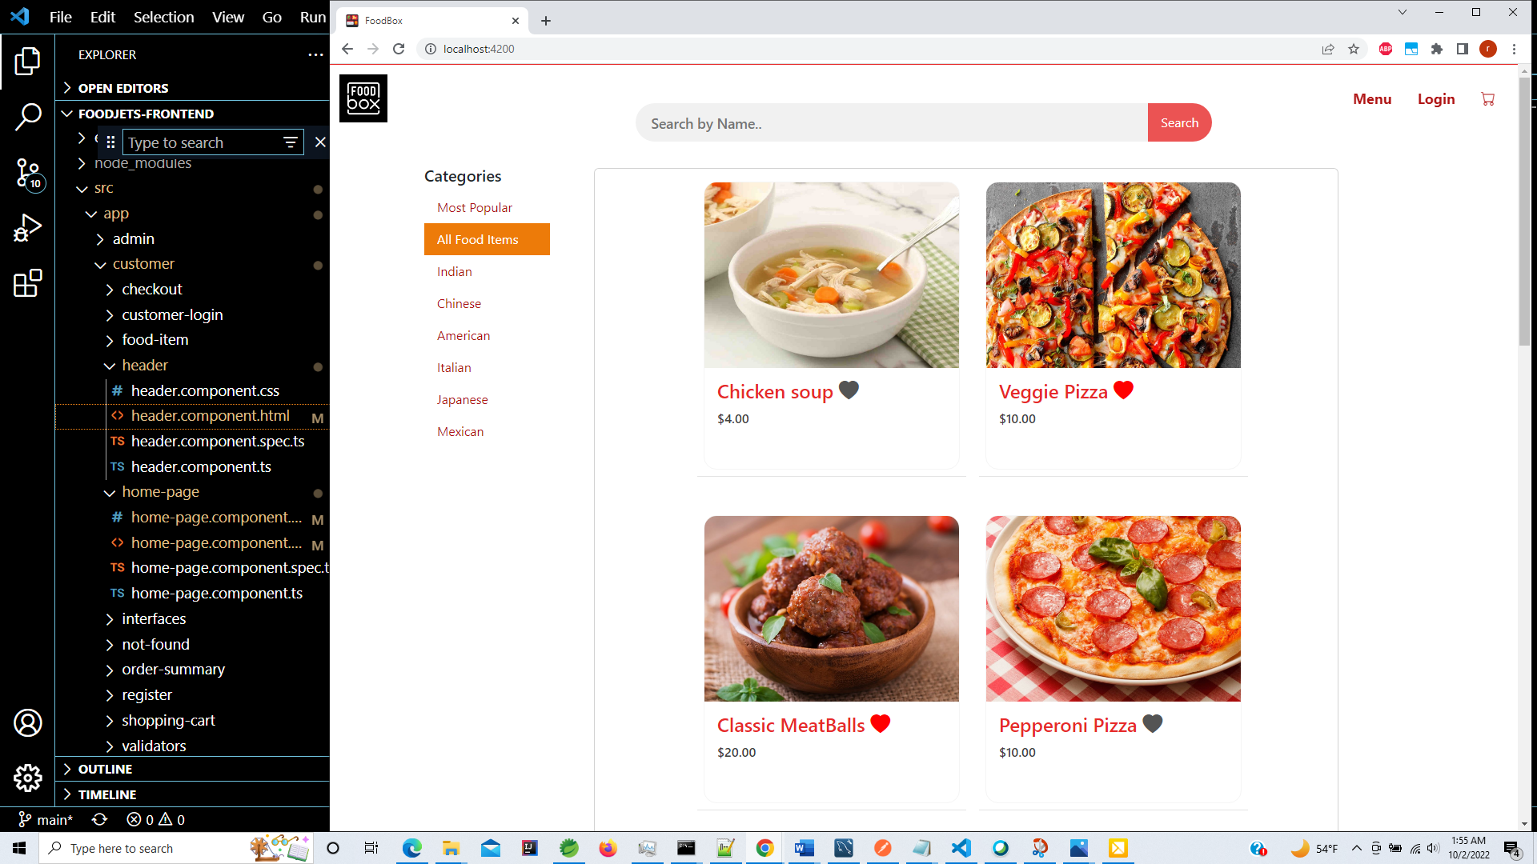

**You can filter specific cuisine items .**

**Will filter and show those items along with price .**

**Heart icon – Indicates the popular items that get ordered often.**

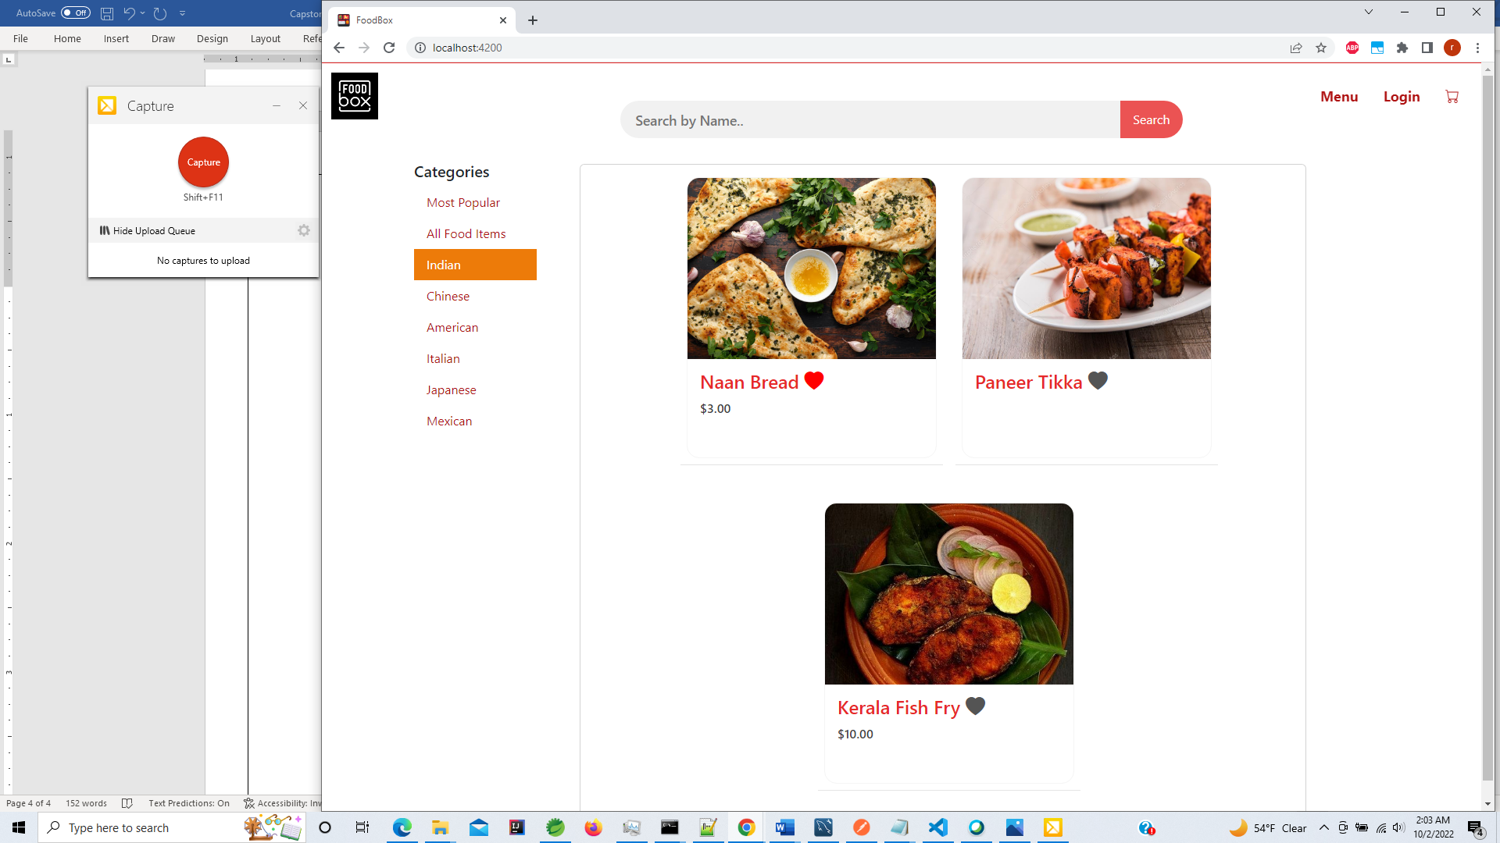

**You can confirm from tha database that it is filtering data correctly based on category name and availabilityTag.**

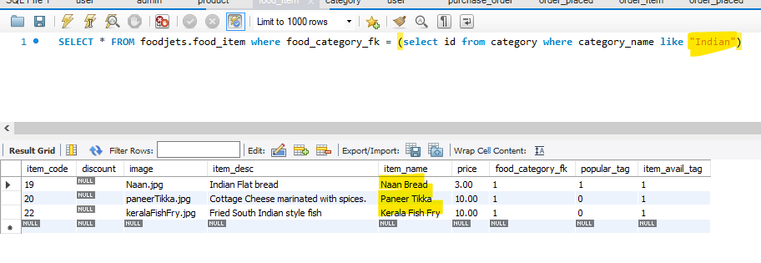

**Search button – allows you to filter items on the page for easy access**

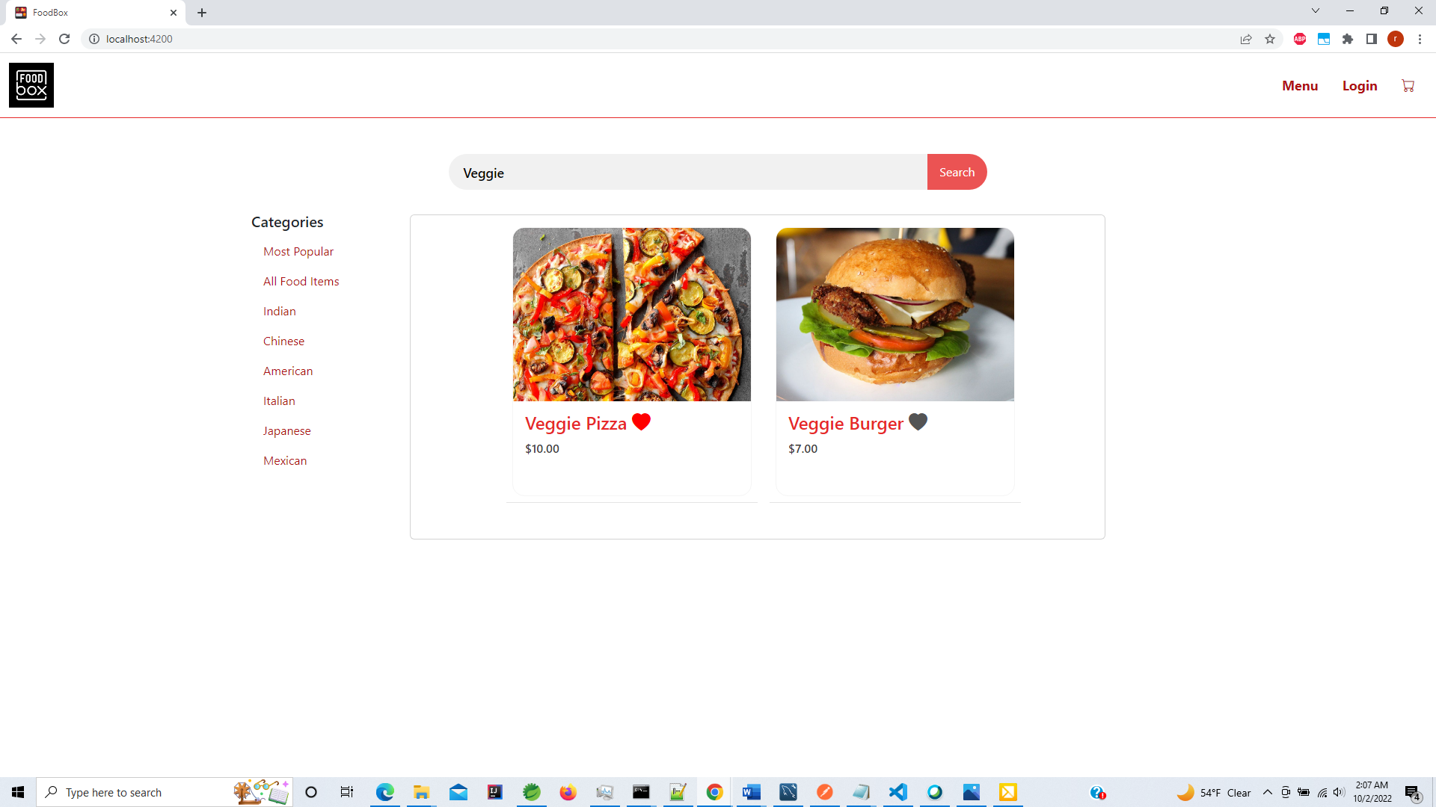

**Search by few characters**

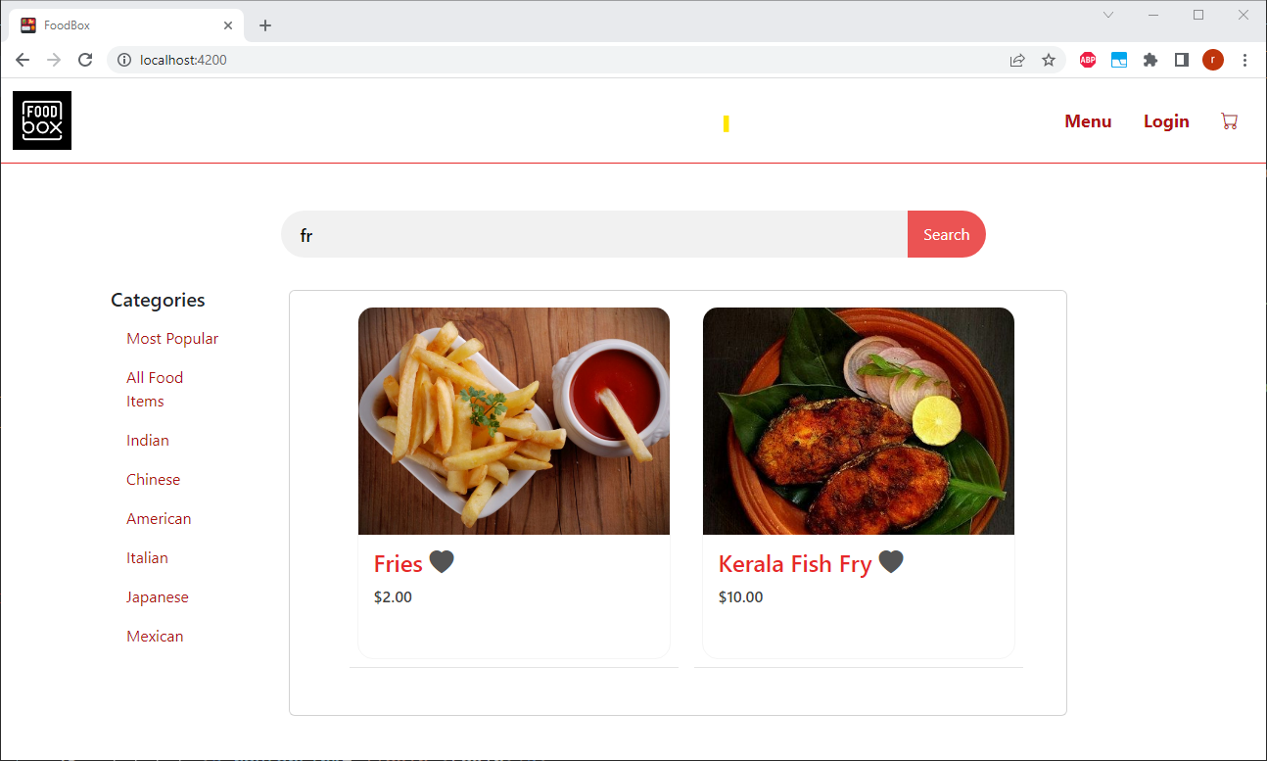

**Shows proper message if no food items match the search key**

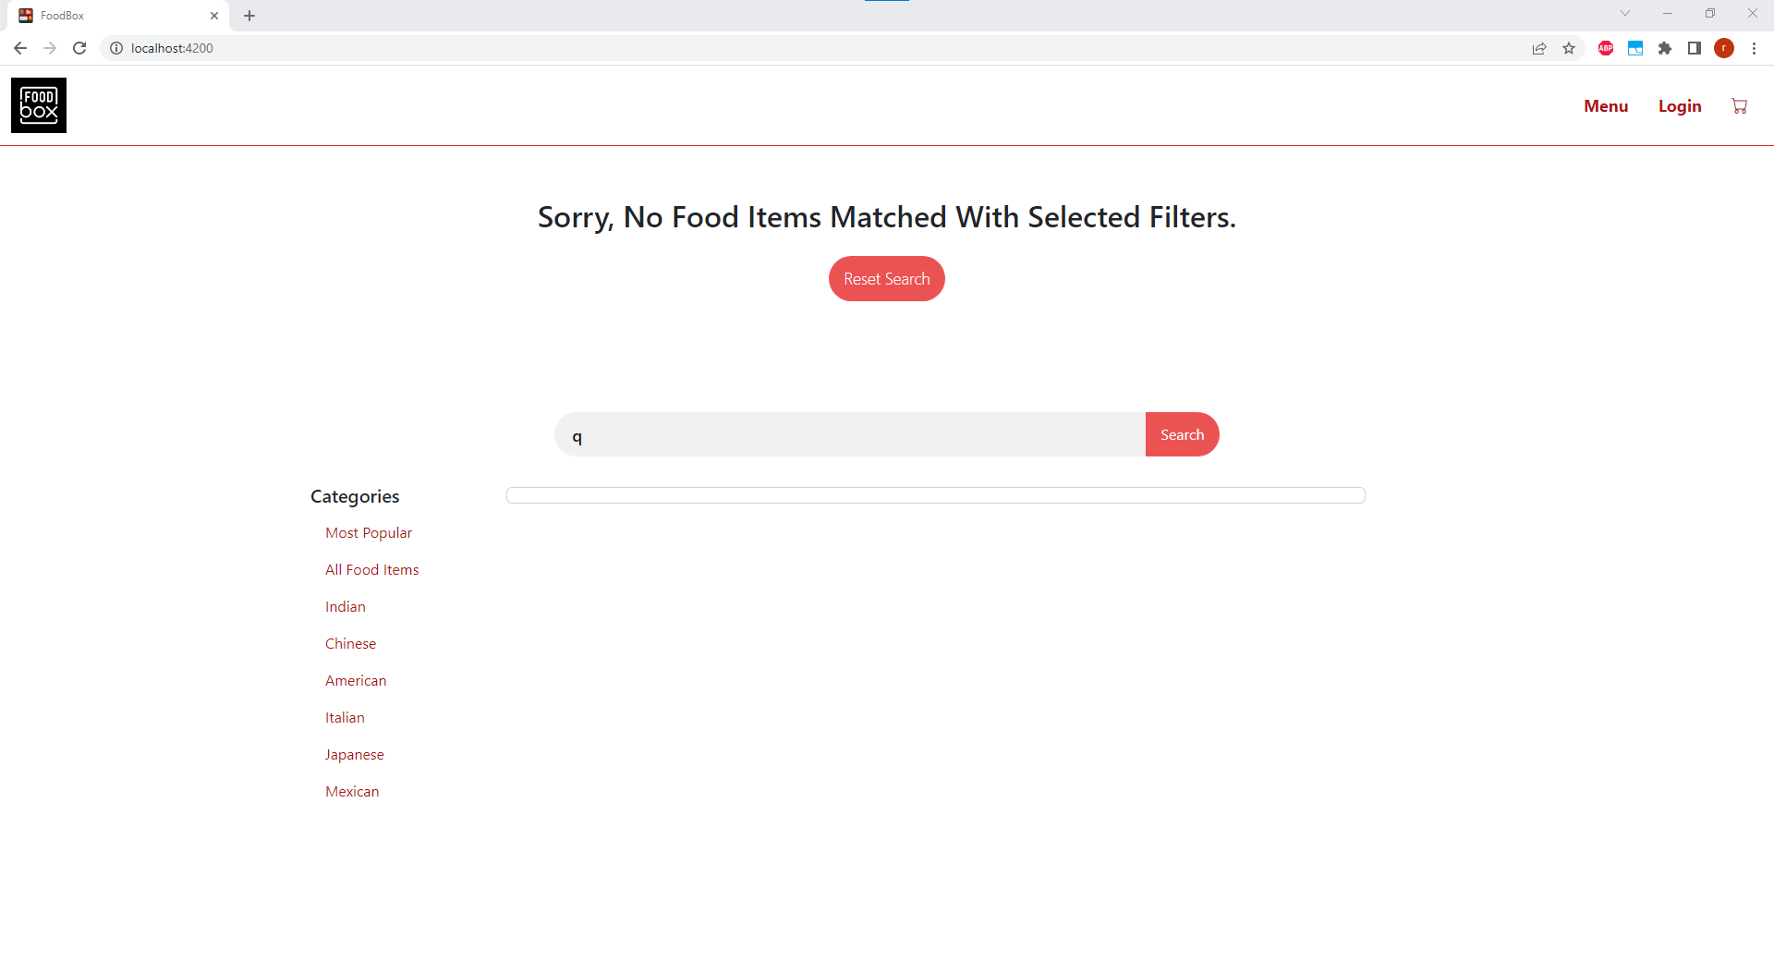

**By clicking on image you can view food item details**

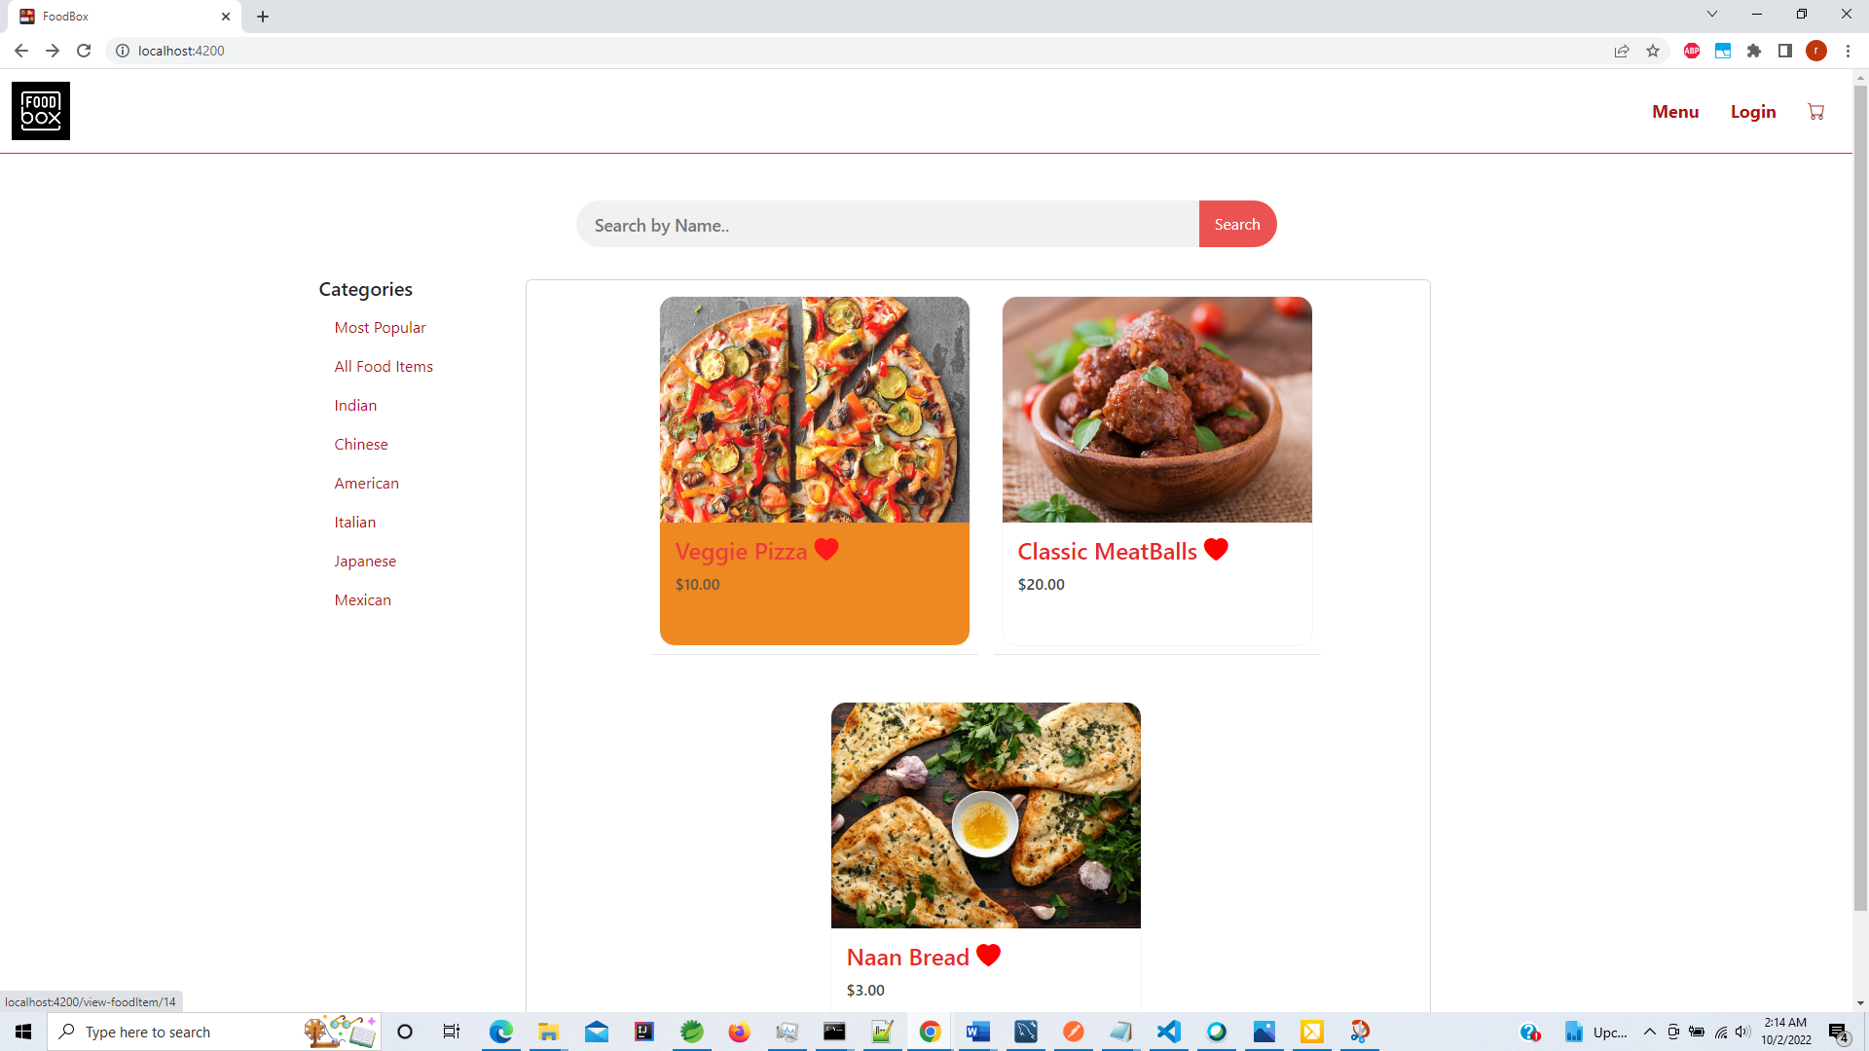

**View food item details**

**Heart – indicates popular item .**

**It shows the food item category, description and price**

**User can also add special request if needed before adding item to cart.**

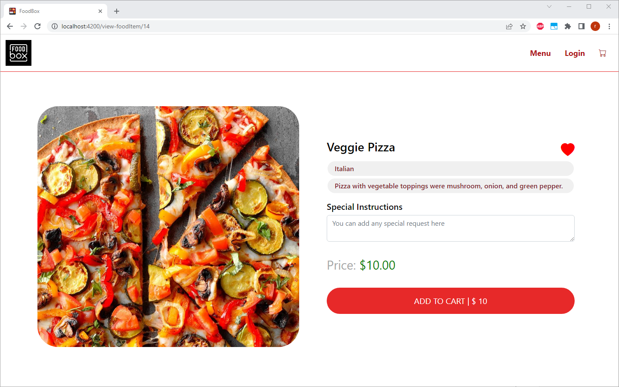

**On clicking Add to Cart the shopping cart is displayed .**

**Also the cart icon on nav bar shows the number of items added .**

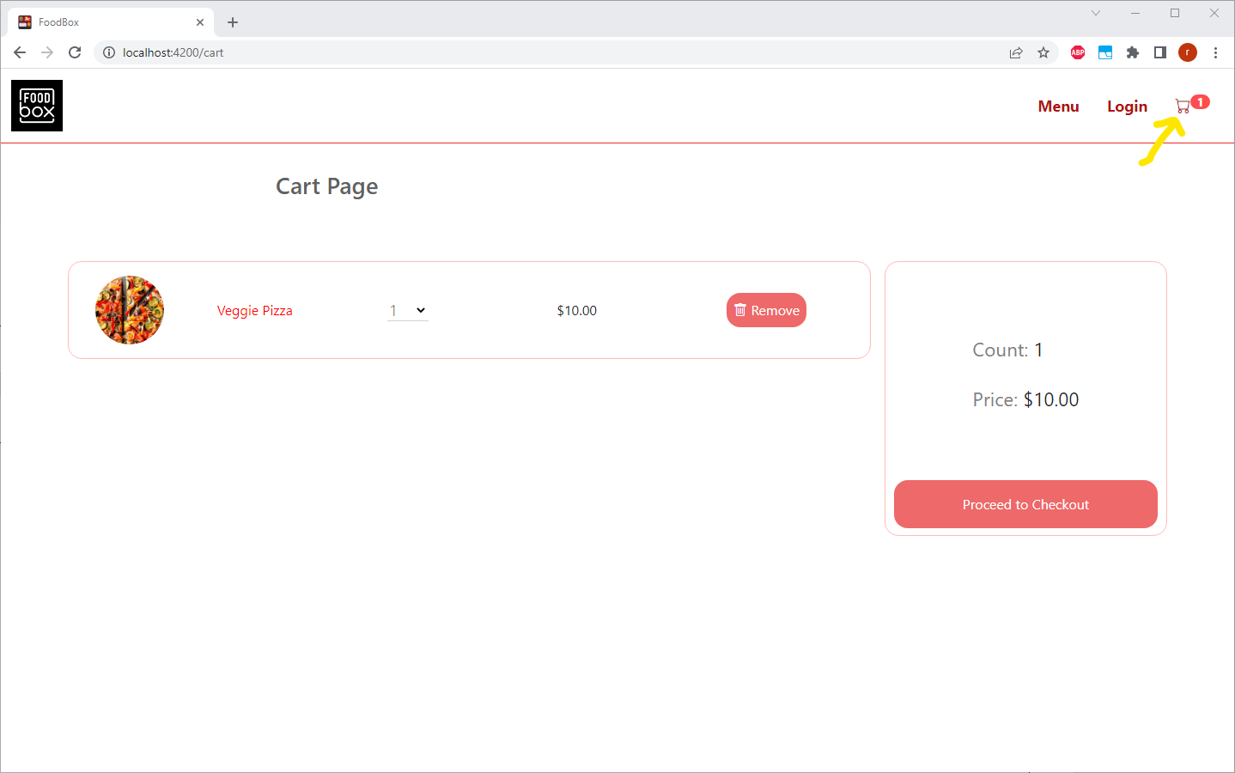

**On updating the quantity the cart is updated as well alongwith price**

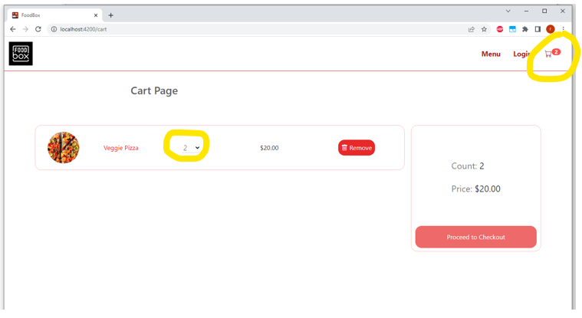

**You can add more items into cart**

**Price ,cart items and quantity updated**

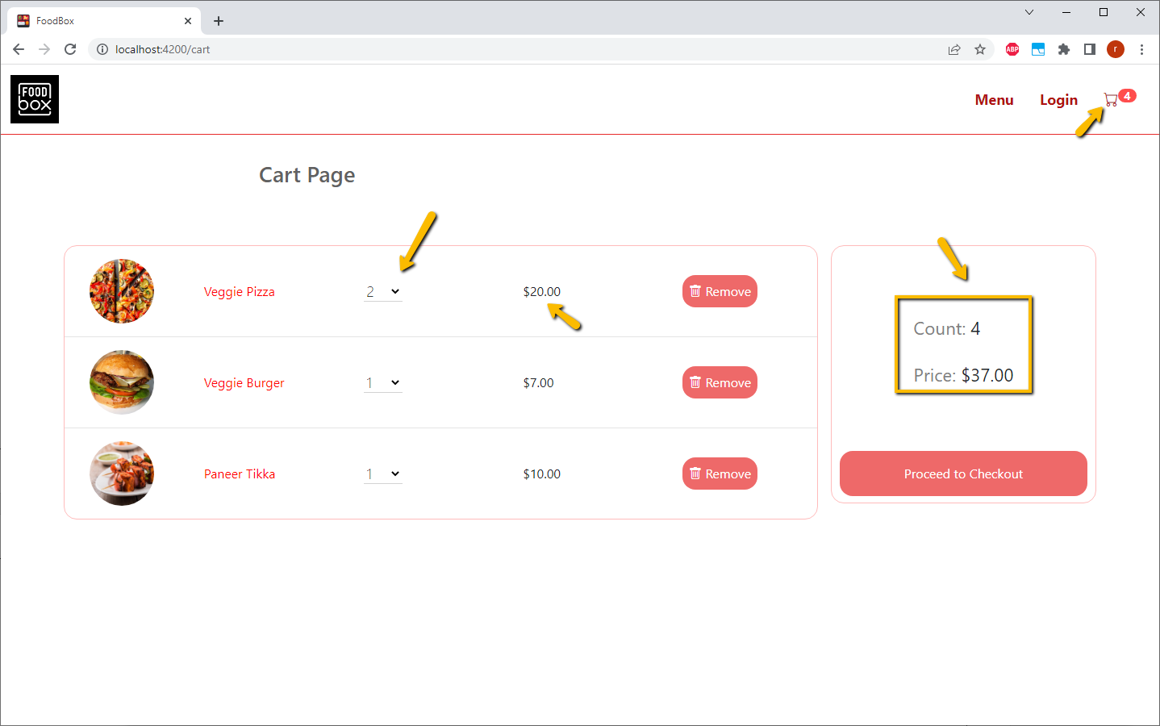

**Delete Item -Remove button**

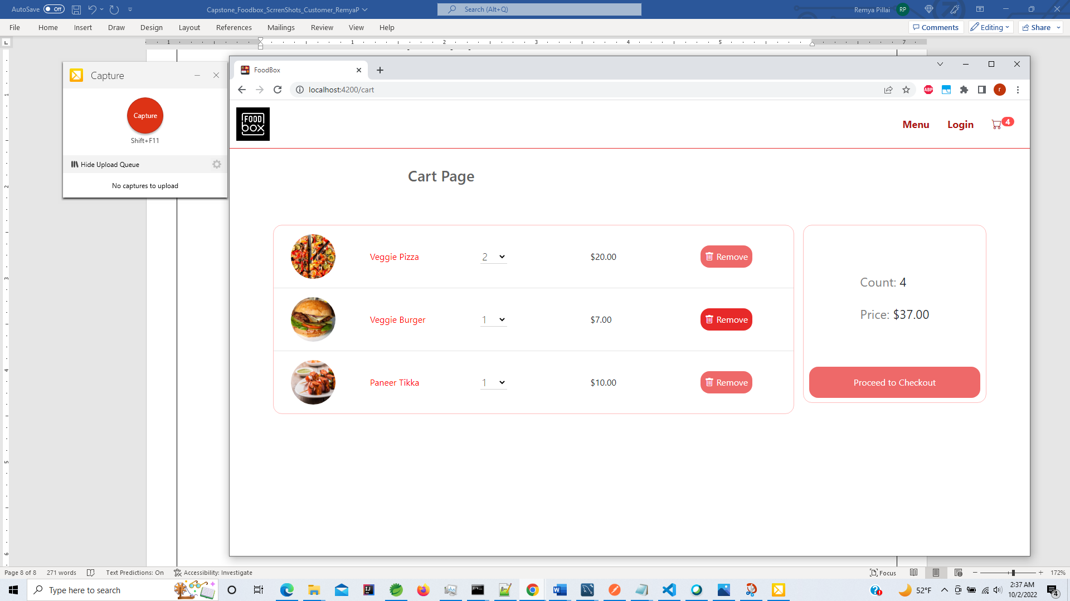

**On deleting the item the cart is updated correctly**

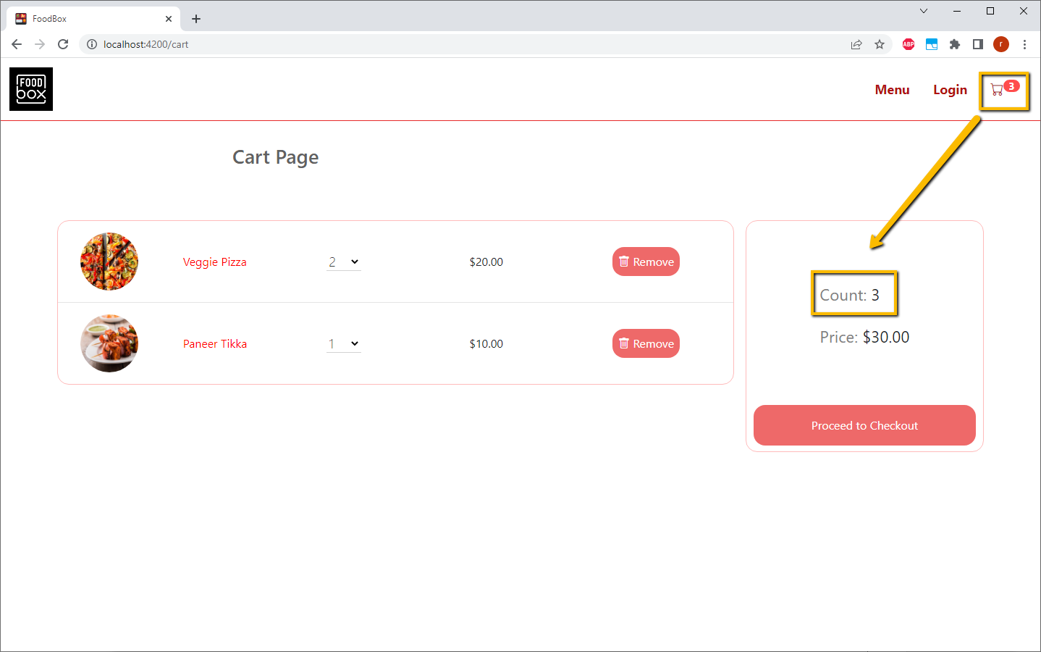

**If we remove all items in cart shows valid message and button to redirect to Menu page**

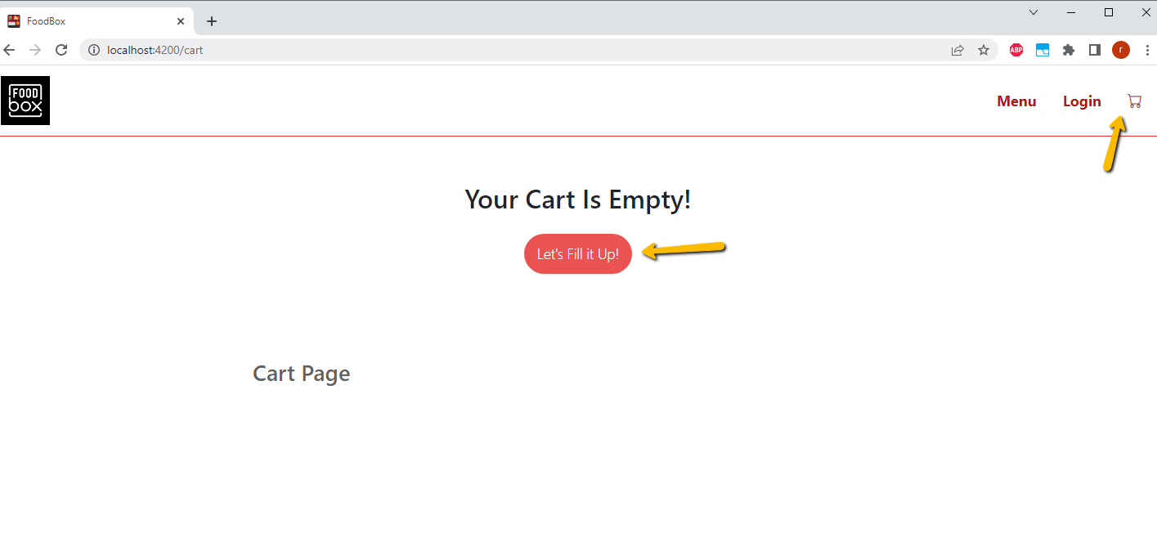

**On Clicking Proceed to checkout and Customer has not logged in -**

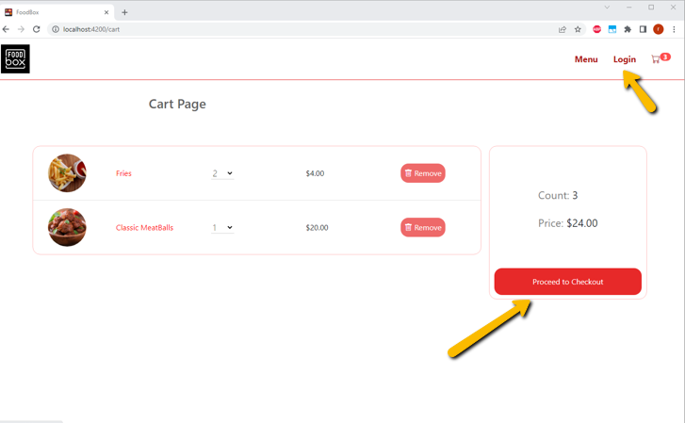

**Customer is redirected to Login Page on checkout if not already logged in to continue with the order**

**Email address and Password are highlighted since they are required fields**

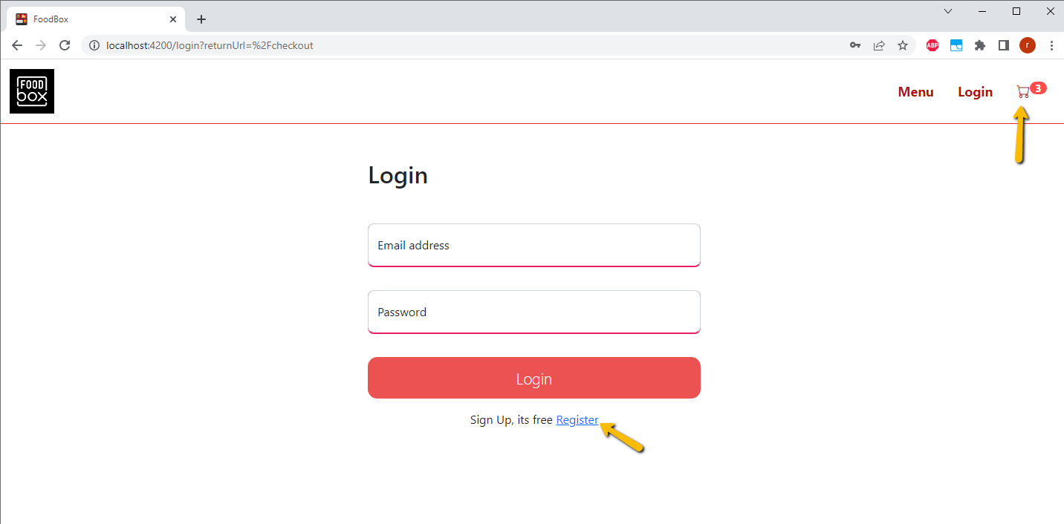

**If credentials are incorrect proper message is shown**

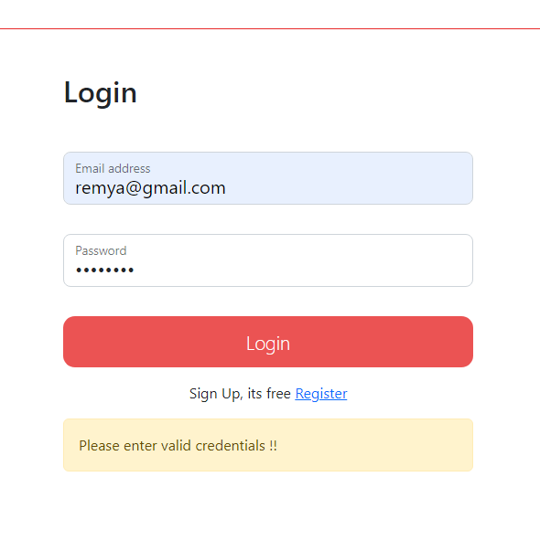

**User has option to register .Since for checkout login is required to proceed**

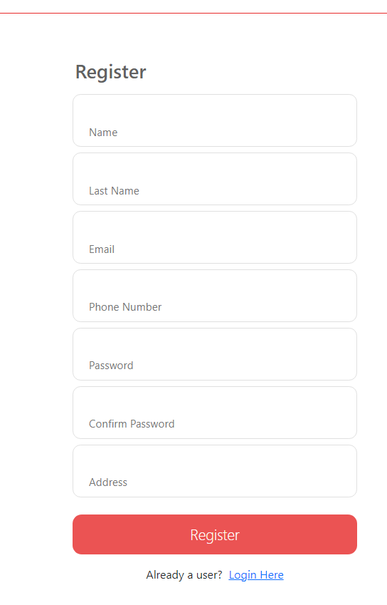

**Proper Validation checks are in place**

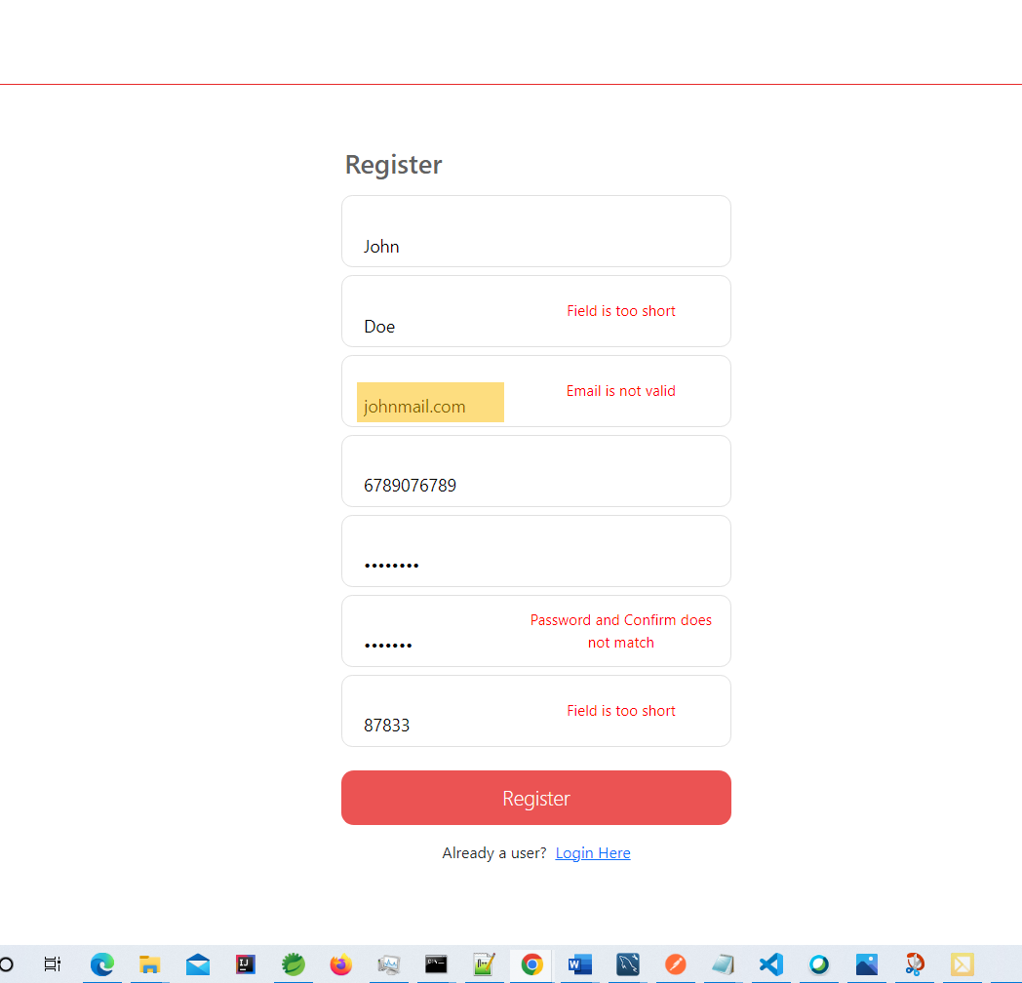

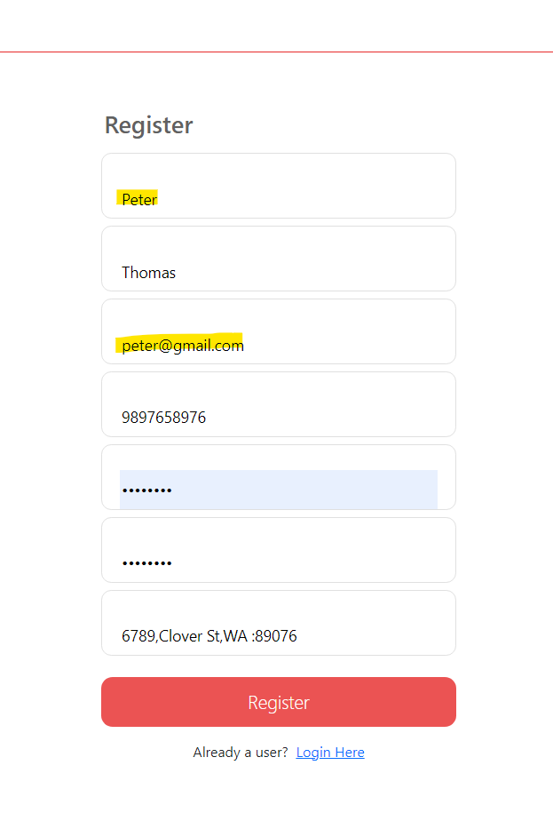

**On successful Register or Login the Name is updated on navbar with items in cart**

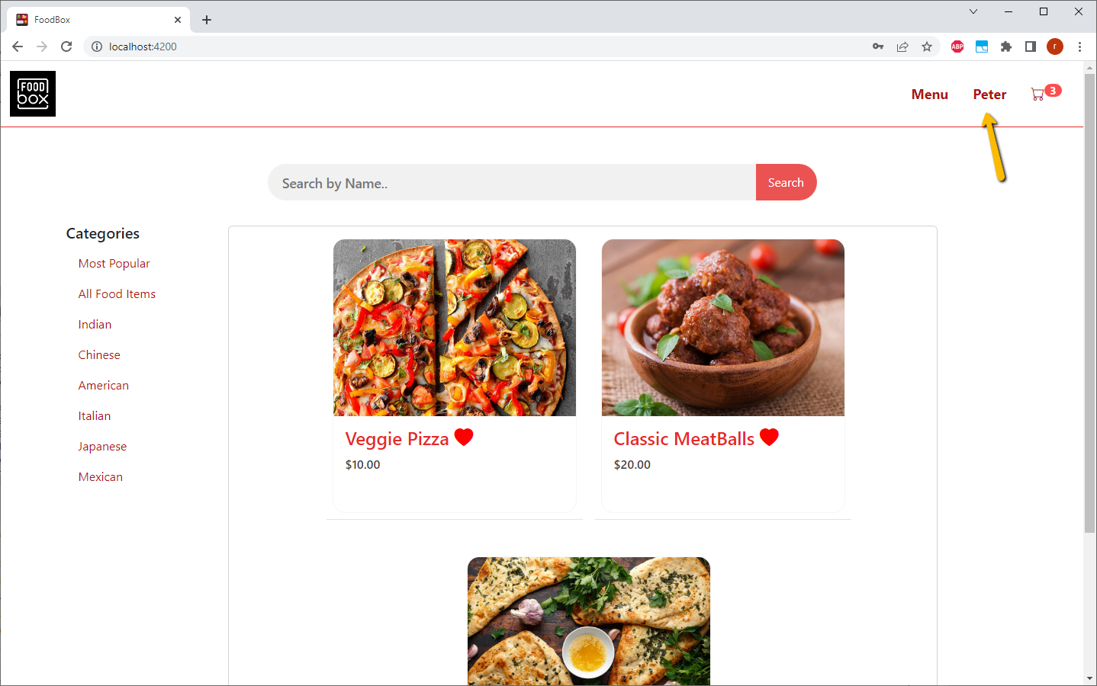

**The logout button is displayed**

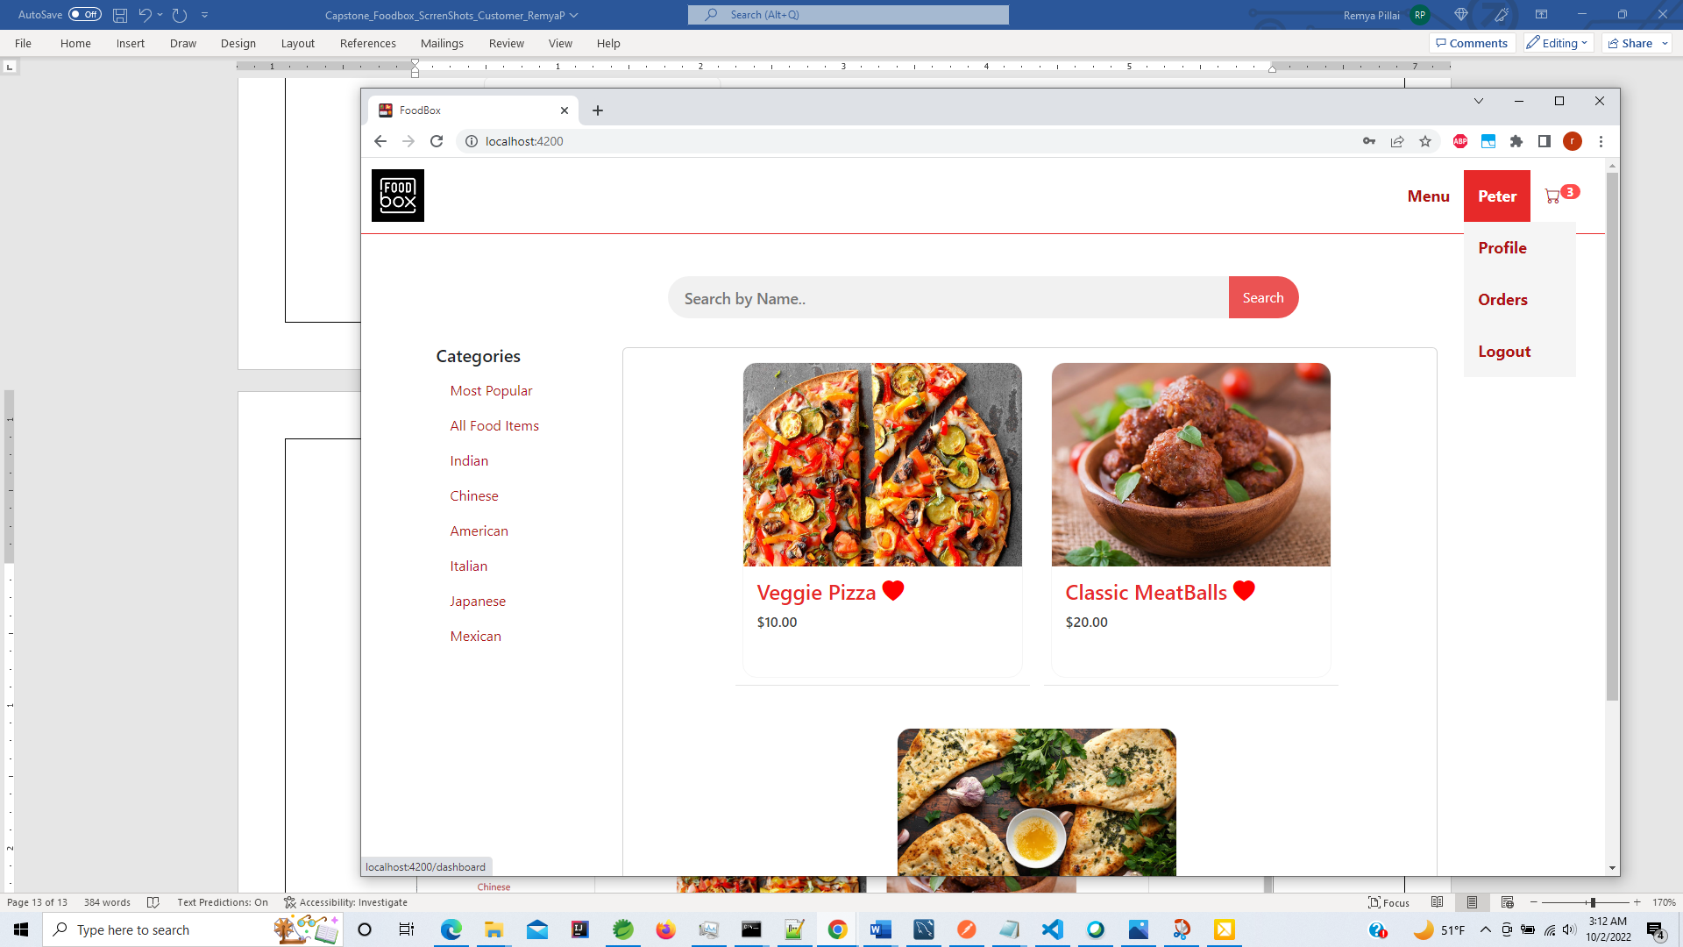

**Proceed to checkout**

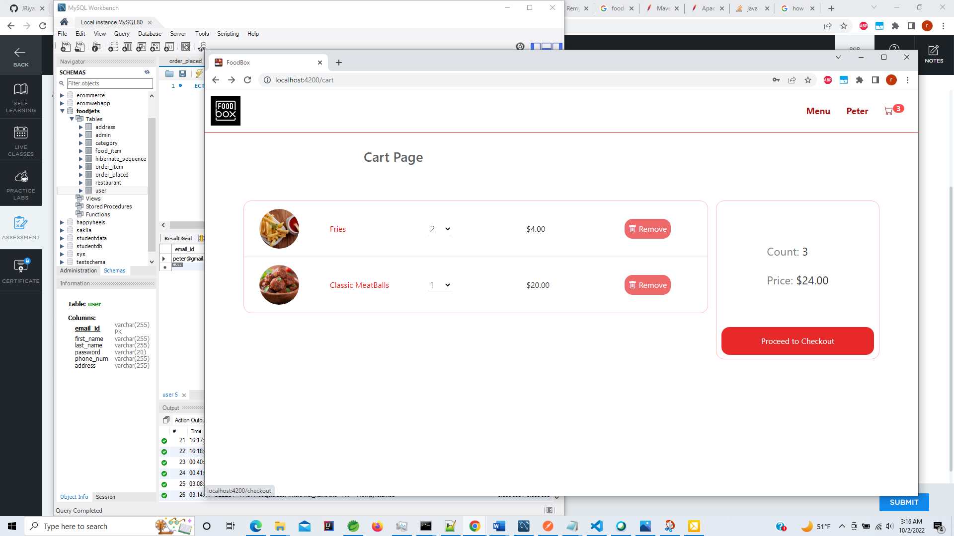

**Checkout page has all Customers default billing information and shows food items included in order.**

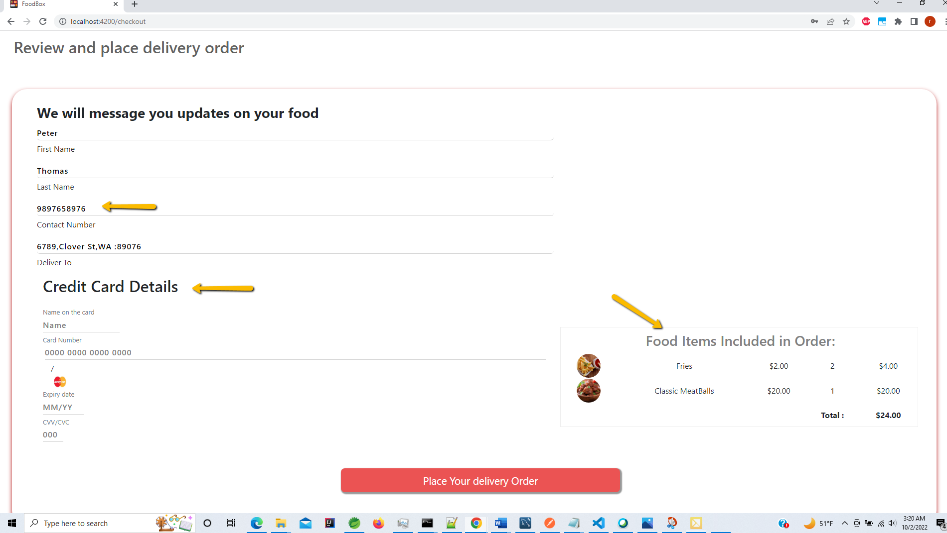

**Customer can update with some other contact information like address and contact number**

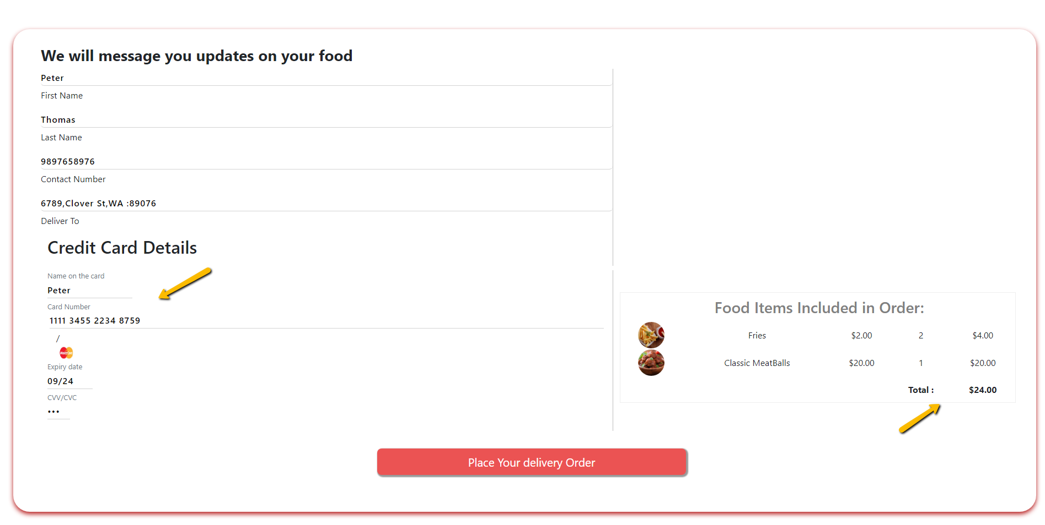

**On Clicking Place Order button :**

**The Customer is redirected to Order Summary page that shows the - Order Number ,**

**Order creation date time and status as order confirmed .**

**Also displays the list of Food items that are included in the order.**

**You can also see that the cart is empty .**

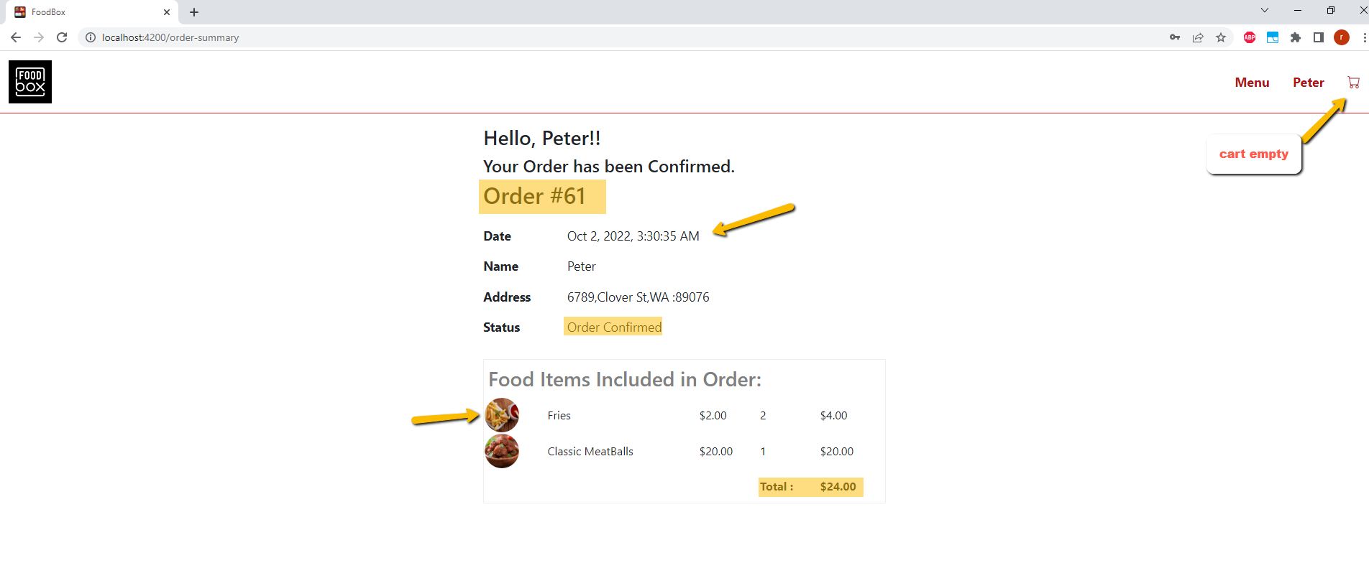

**You can Also confirm in Database the Order details stored in OrderPlaced and Order Item table as shown below**

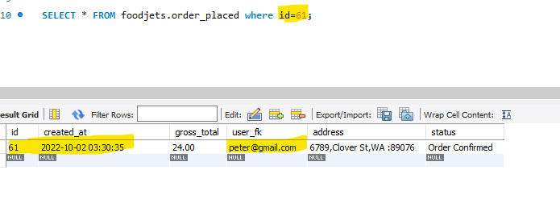

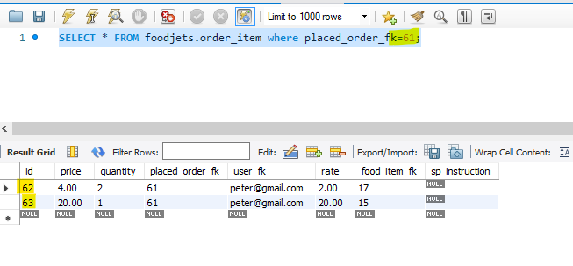

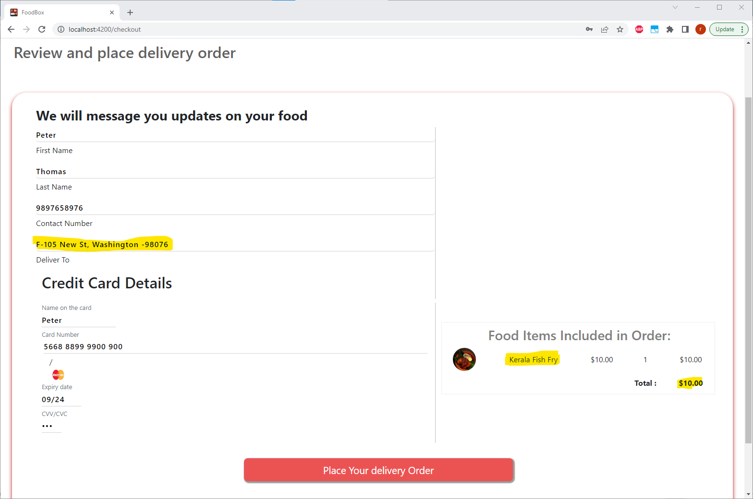

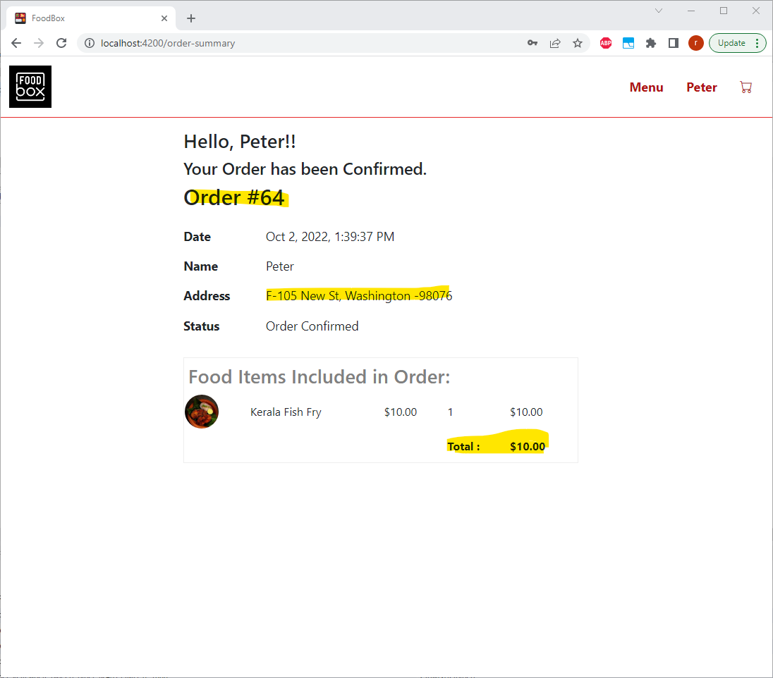

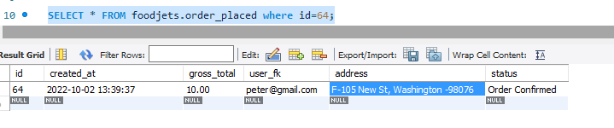

**Now if Customer goes back to previous checkout page proper message is displayed stating that the cart is empty and button to redirect to the Menu page**

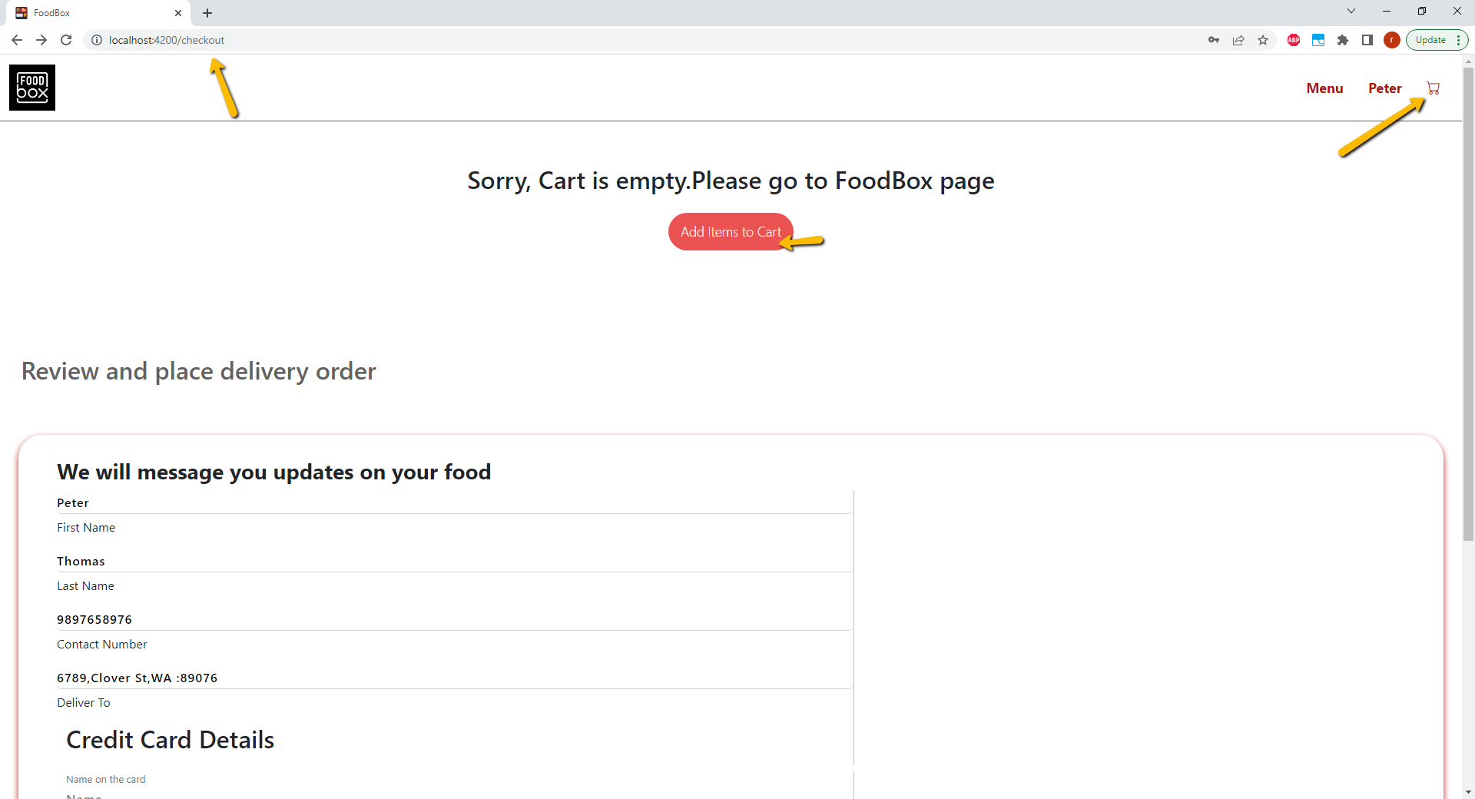

**On clicking Logout button – user is logged out**

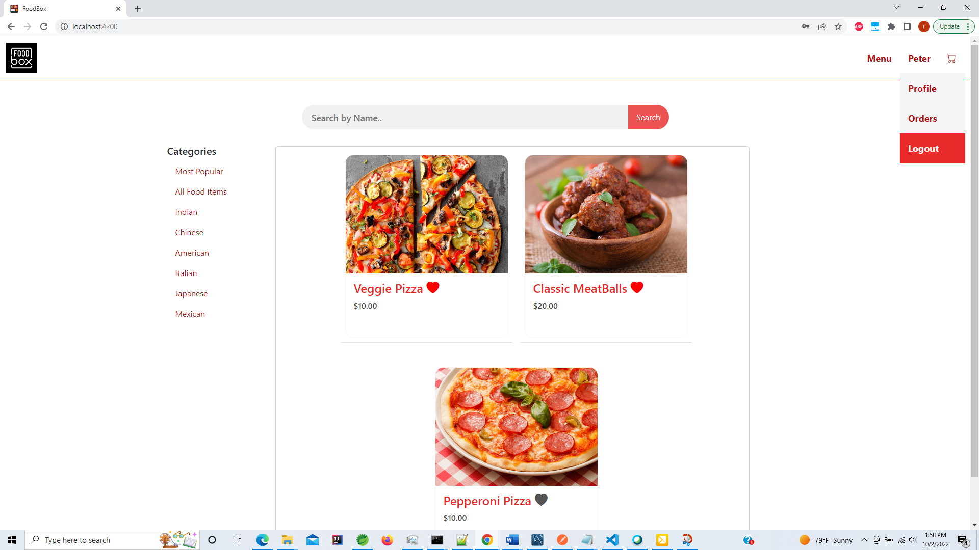

**User is Logged out and Login button is shown in nav bar .**

